# LAB EXERCISE 1

**Copy, move Delete files from different directories.**

**mkdir command:** mkdir command is used to create the folder:

**Example:** $ mkdir Satyajit_28

# Output:-

# 

**cd command :** cd command is used to change the folder:

**Example:** $ cd Satyajit_28

# Output:-

# 

**cat command :** cat command is used to create file, concatenate file, display contents of the file, Copy the file contents into new file, append the contents of File, to copy a file into the same directory**.**

**Example:** $ cat > Friendlist1

**Output:-**

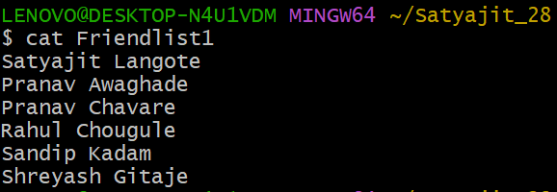

**Example:** $ cat > Friendlist2

# Output:-

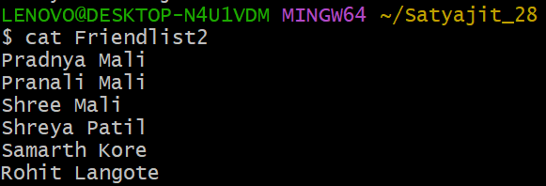

**Example:** $ cat Friendlist1 Friendlist2 > MyFriendlist

**Example:** $ cat MyFriendlist

# Output:-

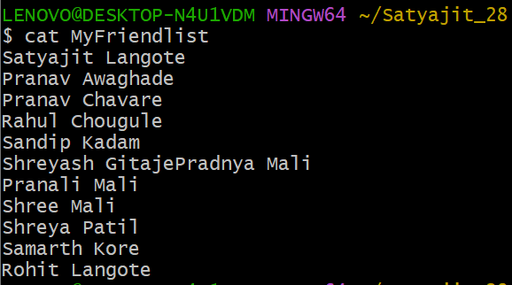

**Example:** $ cat MyFriendlist > NewFriendlist

**Example:** $ cat NewFriendlist

# Output:-

# 

**Cat >>:** To copy the all file content into new file

**Example:** $ cat >> MyFriendlist

# Output:-

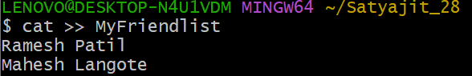

**Example:** $ cat MyFriendlist

# Output:-

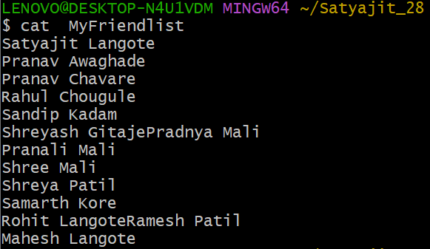

**cp command:** cp command is used to copy file into new file

**Example:** $ cp MyFriendlist CopyFriendlist

**Example:** $ cat CopyFriendlist

**Output:-**

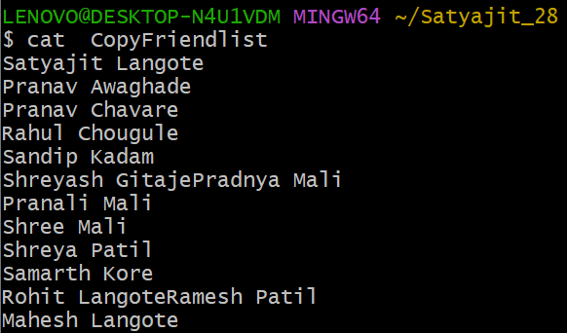

**mv command:** mv command is used for rename the folder, copy the files one folder to another folder:

**Before Rename:-**

**Example:-** $ ls

# Output:-

# 

**Example :-** $ mv NewFreindlist List

**After Rename:-**

**Example:-** $ ls

**Output:-**

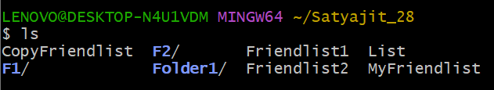

**Example:** $ mkdir Folder2 Folder3

**Example:** $ ls

# Output:-

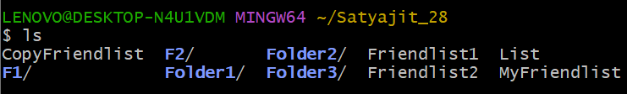

**Example:** $ mv List Folder1

**Example:** $ ls

# Output:-

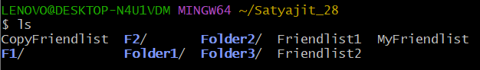

**Example:** $ ls Folder1

# Output:-



**rm command:** rm command is use for remove file from directory, delete files.

**Example:** $ ls

# Output:-



**Example:** $ rm -i CopyFriendlist

# Output:-

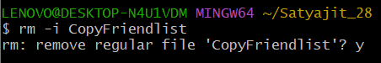

**Example:** $ ls

# Output:-

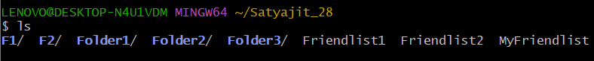

**Search the file using(*):** The asterisk represents any number of unknown character. Use it when searching for documents or file for which you have only partial names.

**Example:** $ ls F*

**Output:-**

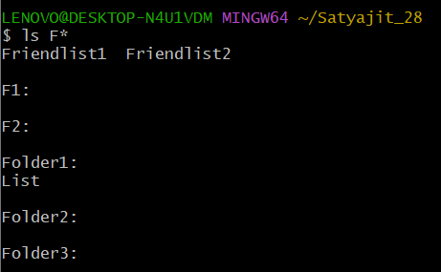

**Example:** $ ls M*

**Output:-**

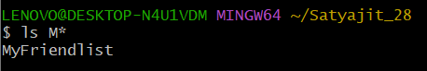

**rmdir command:** rmdir command is used for delete folder from system:

**Example:** $ ls

# Output:-





**Example:** $ ls

# Output:-

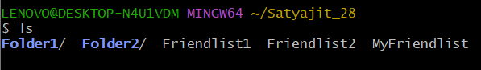

# LAB EXERCISE 2

# Basic Commands

**Date command:** date command is used for displaying dates, displaying the date in string format, displaying the past dates, displaying the future dates.

**Example:** $ date -d "09/30/2024"

# Output:-

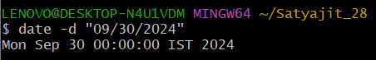

**Example:** $ date -d "2 years ago"

**Output:-**

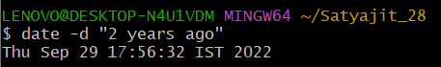

**Example:** $ date -d "10 days ago"

# Output:-

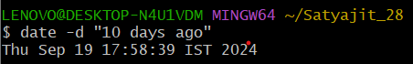

**Example:** $ date -d "2 months ago"

# Output:-

# 

# 

**Example:** $ date --date "next tue"

# Output:-

# 

**Example:** $ date --date "tomorrow"

# Output:-

# 

# 

**Example:** $ date "+%A %B %D"

# Output:-

# 

# 

**wc command:** wc command stands for word count. As the name implies, it is mainly used for counting purpose and their options are used for counting lines, words and characters present in the file.

**Example:** $ wc Friendlist1

# Output:-

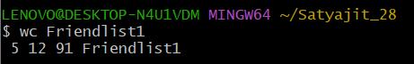

**Example:** $ wc -m Friendlist1

**Output:-**

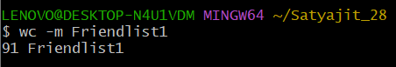

**Example:** $ wc -L FriendList1

# Output:-

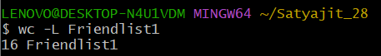

**Example:** $ ls MyFriendlist | wc –l

# Output:-

# 

**whoami command:** whoami command used for to display system’s username:

**Example:** $ whoami

# Output:-

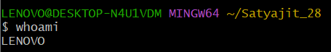

# LAB EXERCISE 3

# Use of filter commands

1. **cut command:** cut command is used for selecting specific column of a file. It is used to cut a specific sections by byte position, character and field.

**Example:** $ cat marks

# Output:-

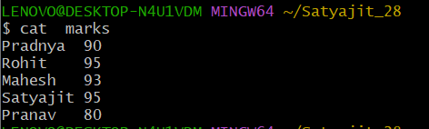

**Example:** $ cut -d ' ' -f2 marks

**Output:-**

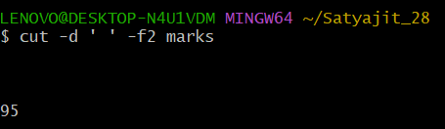

**Example:** $ cut -d ' ' –f1 marks

**Output:-**

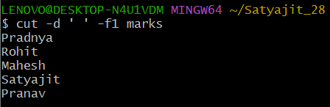

**Example:** $ cut -c 1,3 marks

# Output:-

# 

# 

**Example:** $ cut -c 1-3 marks

# Output:-

# 

# 

# 

**Example:** $ cut --complement -c 1 marks

# Output:-

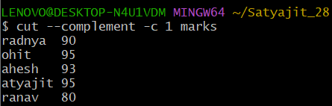

1. **paste command:** paste command is used for merge lines of a files horizontally. It consisting the sequentially corresponding lines of each file specified as an arguments, separated by tabs.

**Example:** $ cat marks

# Output:-

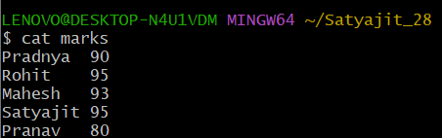

**Example:** $ cat Fmarks

**Output:-**

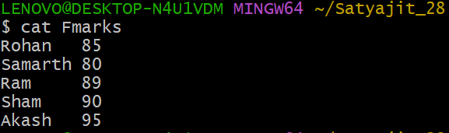

**Example:** $ paste marks Fmarks

# Output:-

# 

**Example:** $ paste -d '_' marks Fmarks

# Output:-

# 

# 

# 

**Example:** $ paste -d '|' marks Fmarks

# Output:-

# 

# 

# 

1. **sort command:** sort command is used for sorting the file contents in an alphabetical and numerical order.

**Example:** $ cat weeks

# Output:-

# 

**Example:** $ sort weeks

# Output:-

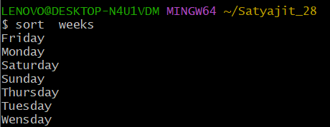

**Example:** $ cat marks

# Output:-

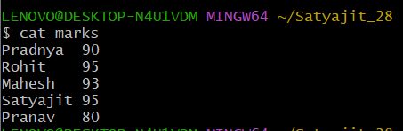

**Example:** $ sort -n -k2 marks

# Output:-

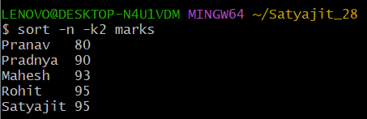

**Example:** $ sort –k1 marks

# Output:-

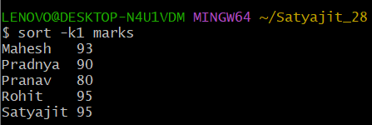

1. **uniq command:** uniq command is used to remove all repeated line from a file. Also, it can be used to display the count of words, only repeated lines, ignore characters, and compare specific field.

**Example:** $ cat demo

# Output:-

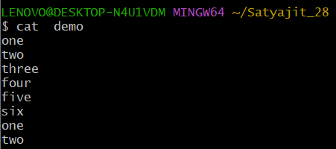

**Example:** $ sort demo

# Output:-

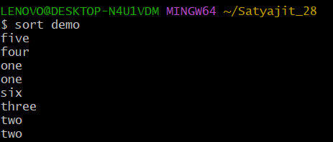

**Example:** $ sort demo | uniq

# Output:-

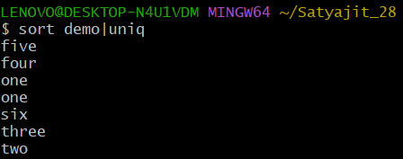

**Example:** $ sort demo | uniq –d

# Output:-

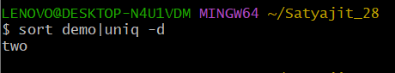

**Example:** $ sort demo | uniq –c

# Output:-

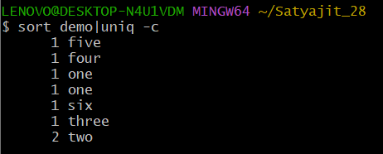

1. **grep command:** grep command stands for “global regular expression print”. grep command filters the content of a file which makes our search easy. grep command is generally used with pipe (|) and without pipe().

**Example:** $ cat marks

# Output:-



**Example:** $ cat marks | grep 9

# Output:-

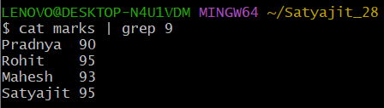

**Example:** $ cat marks | grep 0

# Output:-

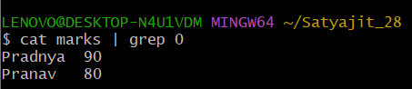

**Example:** $ grep 9 marks

# Output:-

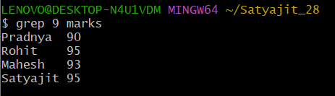

**Example:** $ grep 0 marks

# Output:-

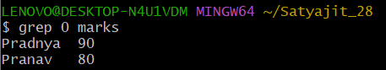

**Example:** $ grep -s 9 marks

# Output:-

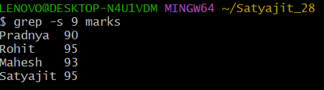

**Example:** $ grep -l h marks

# Output:-

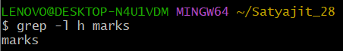

1. **head command**: head command displays the starting 10 lines of a file and display specified number of lines.

**Example:** $ cat numbers

# Output:-

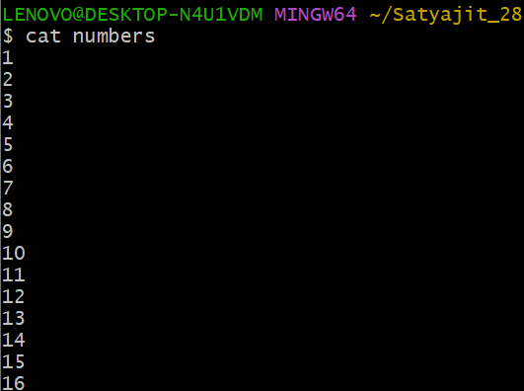

**Example:** $ head numbers

# Output:-

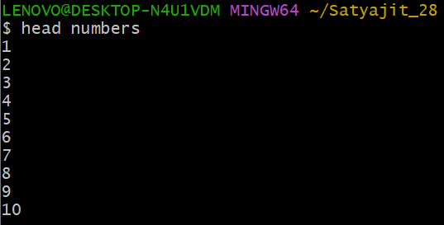

**Example:** $ head -n 5 numbers

# Output:-

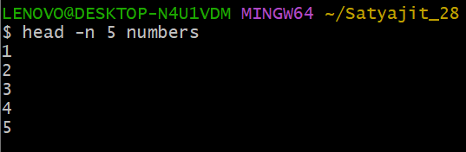

1. **tail command**: tail command displays the last 10 lines of a file and display specified number of lines.

**Example:** $ tail numbers

# Output:-

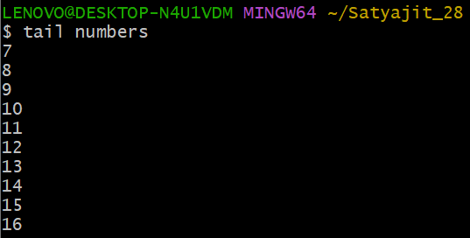

**Example:** $ tail –n 5 numbers

# Output:-

